Health Monitoring with an IoT-Based Wearable

Heet M. Shah  
B.E.(CS) Student  
Birla Institute of Technology and Science PilaniDubai, UAE  
f20210125@dubai.bits-pilain.ac.in

Kailash   
B.E.(CS) Student  
Birla Institute of Technology and Science PilaniDubai, UAE  
f20210@dubai.bits-pilain.ac.in Sachin   
B.E.(CS) Student  
Birla Institute of Technology and Science PilaniDubai, UAE  
f20210118@dubai.bits-pilain.ac.in

line 1: 5th Given Name Surname  
line 2: *dept. name of organization   
(of Affiliation)*  
line 3: *name of organization   
(of Affiliation)*line 4: City, Country  
line 5: email address or ORCIDEthan   
B.E.(CS) Student  
Birla Institute of Technology and Science PilaniDubai, UAE  
f20210081@dubai.bits-pilain.ac.in

*Abstract*—This project focuses on developing an IoT-based wearable device capable of monitoring vital health parameters, including heart rate, blood oxygen saturation (SpO2), and step count, with features for fall detection. The device integrates sensors such as MAX30102 and MPU-6050, an ESP8266 microcontroller for data processing and Wi-Fi communication, and an AWS-hosted MySQL database for data storage. A user-friendly dashboard provides real-time visualization and AI-generated insights using the LLaMA 3-8b-8192 model. This innovative solution aims to empower users with actionable health data and enhance safety and proactive health management. The project addresses pressing needs in the healthcare technology sector, particularly for those requiring continuous monitoring due to chronic illnesses or aging. By combining IoT and AI, it provides a scalable and cost-effective solution, potentially transforming personal health management.

Keywords—component, formatting, style, styling, insert (key words)

# Introduction (*Heading 1*)

The increasing prevalence of wearable technology underscores its potential in personalized health monitoring. With chronic illnesses and aging populations on the rise, there is a growing demand for devices that can deliver continuous and accurate health data. However, current solutions often lack the integration of advanced analytics and real-time feedback, leaving users without actionable insights.

This project addresses these challenges by leveraging IoT to connect high-precision sensors with cloud computing and AI-powered analytics. The wearable device bridges the gap between raw data collection and meaningful health insights, empowering users to make informed decisions about their well-being.

Key objectives of this project include:

* Developing a reliable and cost-effective health monitoring wearable.
* Providing personalized health insights using advanced AI models.
* Ensuring user-friendly design and seamless data accessibility.

# Methodology

## Design

The wearable device is designed with the following components:

1. MAX30102 Sensor:

* Tracks heart rate and blood oxygen saturation (SpO2) using photoplethysmography.
* Designed for low power consumption and high accuracy, making it ideal for continuous monitoring.

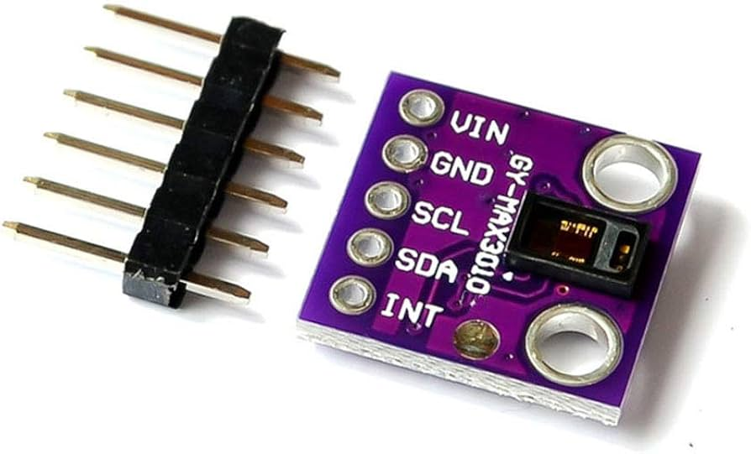

1. MPU-6050 Sensor:

* Tracks step count via a 3-axis accelerometer.
* Includes fall detection capability, providing added safety for elderly users.

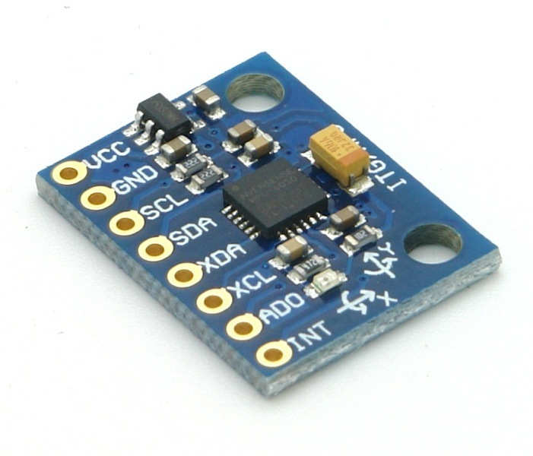

1. ESP8266 Microcontroller:

* Manages sensor data acquisition and Wi-Fi connectivity for real-time data transmission to the cloud.
* Configured for efficient data handling and low latency communication.

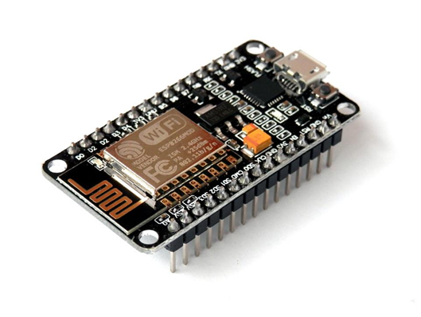

## Schematic Diagram

The schematic diagram illustrates the integration of sensors, microcontroller, and server components. The MAX30102 sensor captures SpO2 and heart rate data, while the MPU-6050 tracks physical activity and detects falls. These sensors interface with the ESP8266 microcontroller, which processes and transmits data to an AWS-hosted MySQL database. The cloud-hosted dashboard visualizes this data in real-time.

## Code

The Arduino sketch processes sensor data and uses the I²C protocol to communicate with the ESP8266. Key functions include:

* Sensor Data Acquisition: Collects real-time data from MAX30102 and MPU-6050 sensors.
* Data Processing: Filters and formats the sensor data for transmission.
* Cloud Communication: Sends data to the AWS-hosted MySQL server via Wi-Fi using HTTP protocols.

The modular code structure ensures easy updates and scalability for future enhancements.

## Dashboard and Insights

A web-based application powered by PHP and MySQL presents :

* Real-Time Visualization: Graphs for heart rate, SpO2, and step count provide a clear overview of health trends.

* AI Insights: The LLaMA 3-8b-8192 model generates personalized health recommendations and predictive analytics, enabling proactive health management.

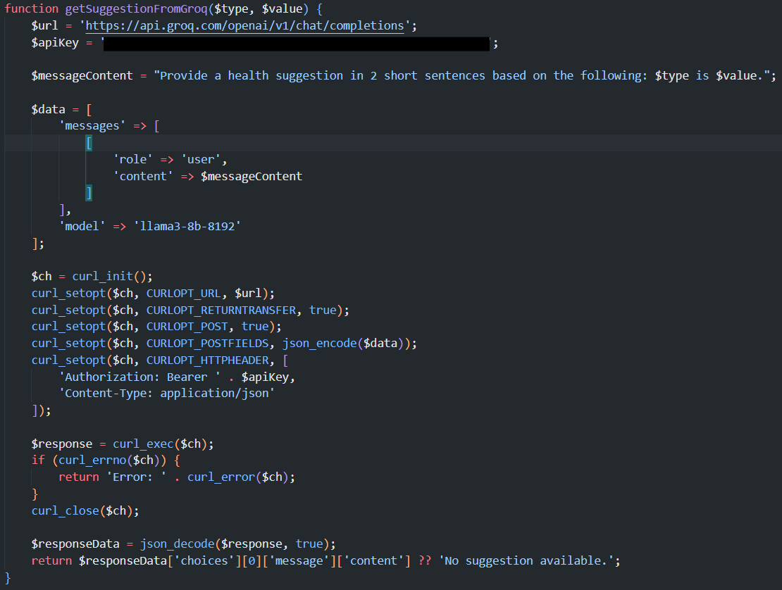

The dashboard design emphasizes user-friendliness, with interactive elements for exploring detailed data insights.

## Equations

1. Acceleration Magnitude

$$\sqrt{x^{2}+y^{2}+z^{2}}$$

Where, x, y, z are Acceleration components from the MPU-6050 sensor

1. Heart Rate (BPM)

$$BPM=\frac{6000}{Crossed time-last heartbeat}$$

Crossed time: Time of the current detected peak

Last heartbeat: Time of the previous detected peak

1. SpO2 Calibration

$$SpO2=AR^{2}+BR+C$$

Where,

* + R = $x=\frac{(\operatorname{Max}{Red-Min Red)/Avg Red}}{\frac{\left(Max IR-Min IR\right)}{Avg IR}}$
  + A, B, C: Calibration constants (A= 1.5958422, B= −34.6596622, C= 112.6898759).

# Results and Discussion

## Results

Since this project was a prototype and not extensively tested, the results focus on the system’s theoretical functionality and initial evaluations during the development process:

1. Sensor Integration:

The MAX30102 and MPU-6050 sensors were successfully integrated with the ESP8266 microcontroller, demonstrating proper data acquisition during testing.

1. Data Transmission:

Data was transmitted reliably from the ESP8266 to the AWS-hosted MySQL database in a simulated environment.

1. Dashboard Performance:

The dashboard accurately displayed the collected data in real-time, including visualizations such as graphs for heart rate, SpO2, and step counts.

## Discussion

The project primarily aimed to demonstrate the feasibility of a wearable IoT-based health monitoring system. While the prototype showed promising initial functionality, several considerations emerged:

1. Prototype Limitations:

* The system was not tested with live, continuous usage due to time and resource constraints.
* Calibration of sensors for real-world scenarios remains to be explored.

1. User Interface:

* The dashboard’s interface was basic but functional. Improvements in visual design and user experience could enhance accessibility.

1. AI Insights:

* The AI-generated insights were based on hypothetical data. Testing with actual user data is necessary to validate the accuracy of recommendations.

# Challenges and future work

## Challenges

1. Battery Optimization:

* Power consumption is a critical factor in wearable devices. Ensuring prolonged device operation without frequent recharging requires the integration of low-power sensors and optimized communication protocols.

1. Sensor Calibration:

* Accurate health monitoring relies on precise sensor readings. Fine-tuning sensor calibration for various environments and user conditions remains a significant challenge.

1. Data Transmission Stability:

* While the prototype demonstrated stable transmission in a controlled environment, testing in areas with inconsistent Wi-Fi connectivity may reveal reliability issues.

1. User Engagement

* Ensuring users understand and trust the health insights provided by the device is vital. The AI-generated recommendations need thorough validation for user confidence.

## Future Work

1. Improved AI Algorithms:

* Incorporate advanced machine learning models to enhance health insights, enabling predictive analytics for early detection of potential health issues.

1. Additional Sensors:

* Integrate sensors to monitor more health metrics, such as skin temperature, blood pressure, or hydration levels, providing a more comprehensive health profile.

1. Mobile App Integration:

* Develop a companion mobile application for improved accessibility and user interaction with health data.

1. Environmental Testing:

* Conduct extensive testing across different conditions, such as varying temperatures, altitudes, and humidity levels, to ensure robust performance.

1. Scalability and Cloud Optimization:

* Enhance the cloud infrastructure to support multiple users simultaneously while maintaining data security and quick response times.

The prototype effectively demonstrates the concept of IoT-enabled health monitoring, laying the groundwork for future enhancements and real-world applications.

# Conclusion

This IoT-based wearable health monitor delivers real-time health monitoring, empowering users with actionable insights. By integrating IoT, cloud computing, and AI, the system addresses critical needs in personal health management. Future enhancements will focus on:

* Incorporating additional sensors for broader health monitoring capabilities.
* Enhancing AI algorithms for more detailed and predictive insights.
* Improving energy efficiency to extend device usage time.

This innovation lays the groundwork for a more proactive approach to health management, bridging the gap between technology and personal well-being.

# References

* Cacsdcvcv
* Acadcv
* Dcsdc
* Svsdv